Week 5 – Hardware Development Update

Document Version Number: 3.0

Date: March 28th

Author: Yu Chen Xu

Hardware Version: 3.0

Goal: To explain the updated version of physical model.

Contents

Side sensor placement 2

# Side sensor placement

In this week, the major mechanical update is the modification of the position of the side ultrasonic sensor. Instead of putting the side sensor in perpendicular with the front of the robot, it is now at the 45º on the left of the robot.

Before

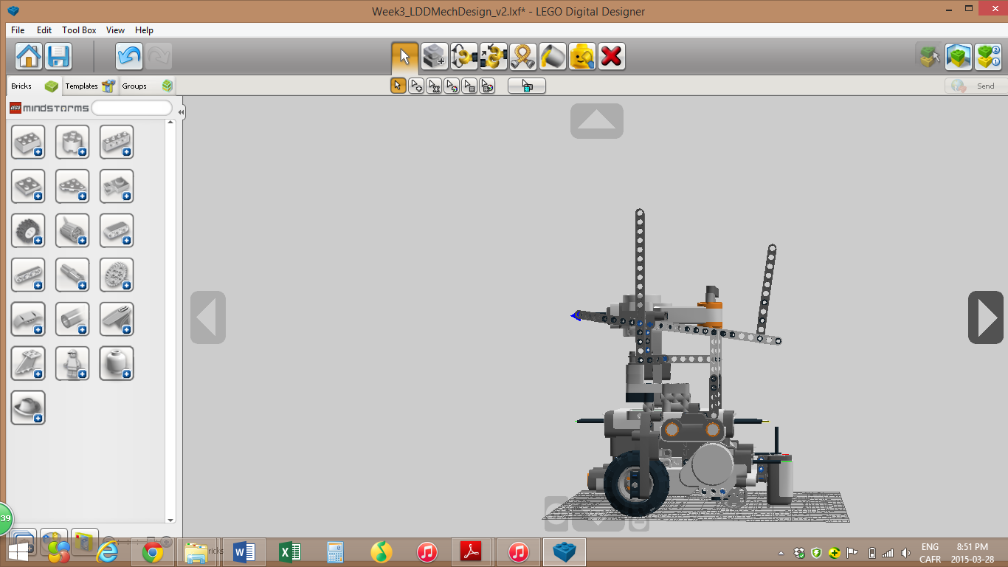

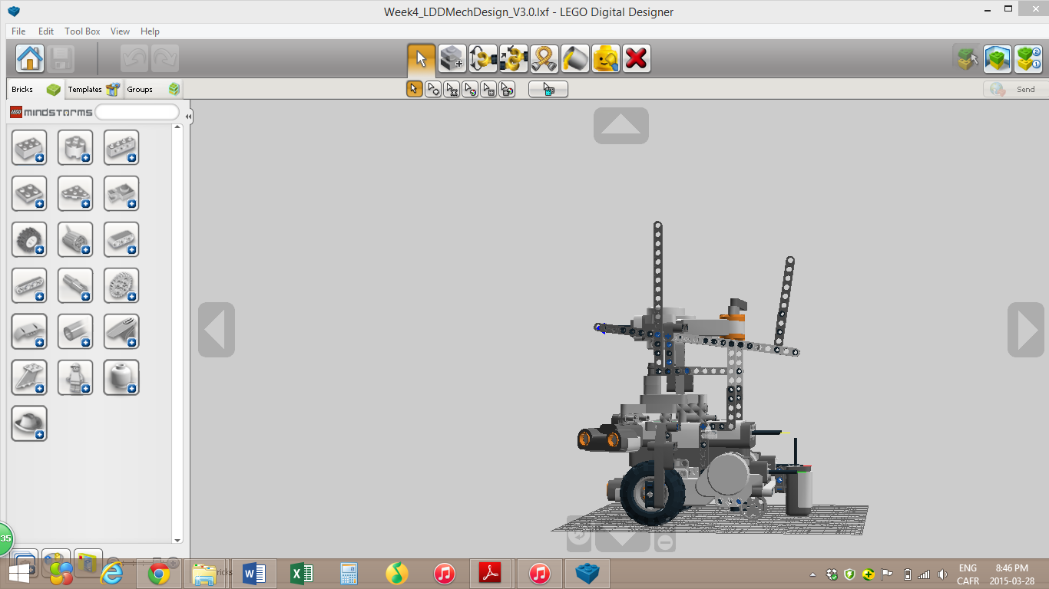After

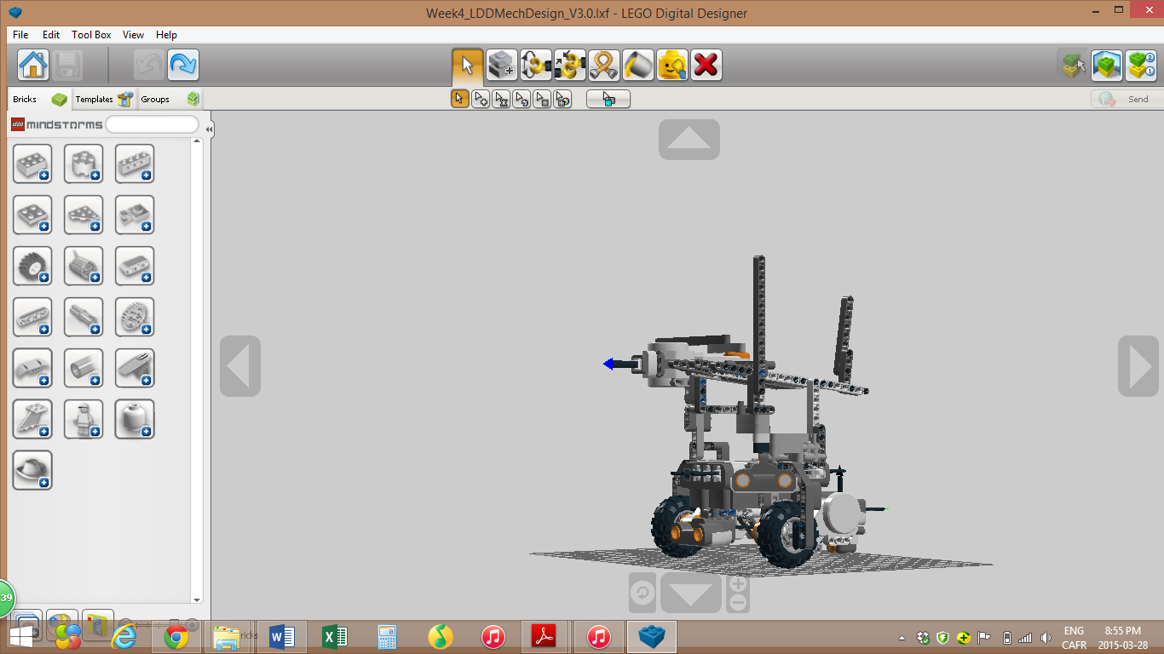

In fact, the software team decided that putting the sensor at 45º will be beneficial when avoiding obstacles. In the previous mechanical model version, only the front sensor is used to detect obstacles. Therefore, it is difficult for the front sensor to detect obstacles on the sides. For example, in the situation represented by the image below, the front sensor has a very high chance of not detecting the block on the left. As a result, the robot will hit the obstacle.

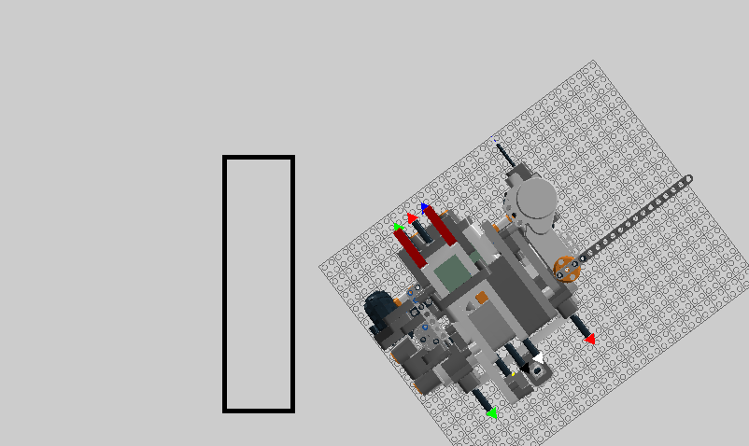

With the new model, the side sensor will detect the obstacle even if the front one does not see it. Therefore, the robot will make its own adjustment. To sum up, the new model has a bigger range of coverage, then not only limited by the front sensor.

